Name: _________________________________________ Date: __________________________
Vet Science I
Study Guide #2 (H)
- What do the following words mean?
- Derma-:

- Pil-:

- Onych-:

- Ungul-:

- Eu-:

- Dys-:

- -ist:

- -opsy:

- -scope:

- -osis:

- What is the INTEGUMENTARY system?

- Name 3 FUNCTIONS of the integumentary system

- What are the 5 parts of the body that make up integumentary system?

- Please label the following parts of the integumentary system:
-dermis -epidermis -hypodermis -hair shaft
-hair follicle -sweat gland -sebaceous gland -arrector muscle
-fat cells -blood vessel

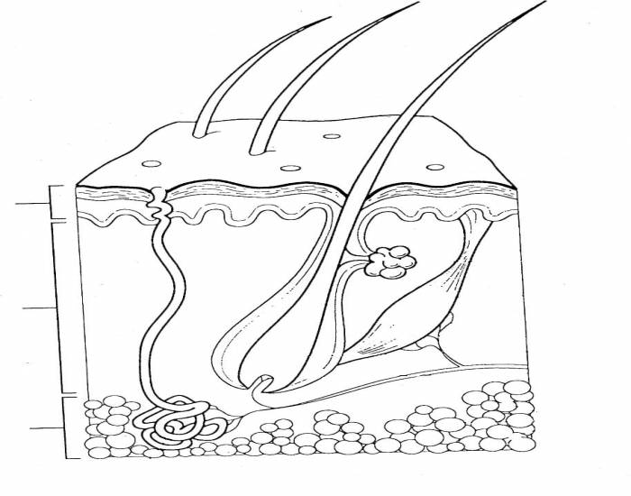

6. Which layer of skin contains all of the important structures, including glands, blood vessels and nerves?

7.What is the purpose of MELANOCYTES within the skin?

8. Which layer of skin is where injections can be given?

9. What is a GLAND?

10. What is the purpose of the different glands found in the skin?
- Sebaceous Gland:

- Sweat Gland:

11. Do dogs sweat? WHY or WHY NOT? How do they cool off?

12. What are the three FUNCTIONS of hair?

13. What are the 3 types of hair that an animal can have? Know a definition for each type:
Hair Type Definition

14. What is the difference between Shedding and Alopecia?

15. What are the following grooming tools related to the integumentary system?
Word Bank: Hair Clippers, Body Brush, Pet Grooming Scissors, Kong Zoom Groom, Nail Clippers, Curry Comb, Hoofpick with brush, Dremmel, Shedding Blade

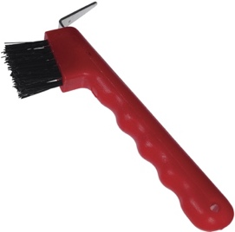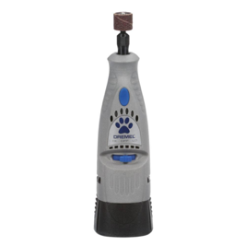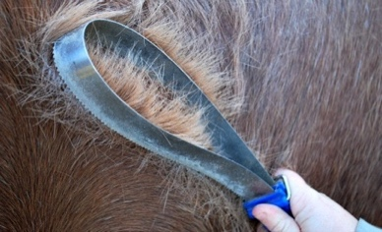

__________________________ _____________________ ____________________

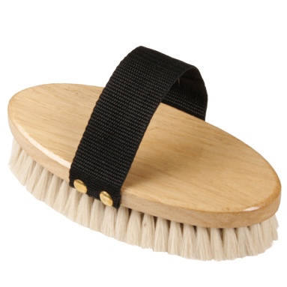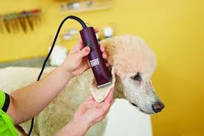

__________________ ___________________ ________________ ______________

_________________

16. What are the two FUNCTIONS of nails?

17. What is the QUICK? Why is this structure important when trimming an animal’s nails?

18. If you accidently hit the quick, what product(s) that was talked about in class can you use to stop the bleeding?

19. What does the term First Aid mean?

20. What are the 4 reasons why an animal might need pet first aid?

21. What are the 15 things found in a pet first aid kit?

22. What does CPR stand for?

23. What are the ABC’s of performing CPR?

24. What are the 4 purposes of a bandage?

25. Be able to perform the following first aid procedures:
- CPR (animal that has no pulse/not breathing)
- Temperature

26. What are the 3 layers of a bandage? What is the purpose of each layer?
Bandage Layer Purpose

27. What are the following veterinary tools related to the integumentary system and first aid?
Word Bank: Elastic Bandage, Gauze Pads, Basket Muzzle, Stethoscope, Tourniquet, Vet Wrap, Forceps, Tweezers, Nylon Muzzle, Trauma Sheers, Gauze Roll

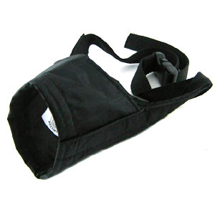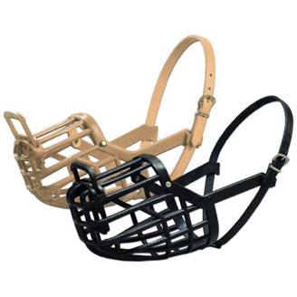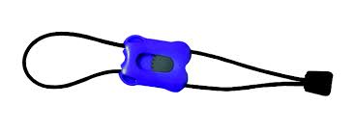

__________________________ _______________________ _______________________________

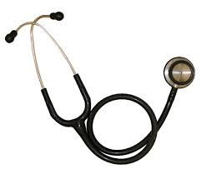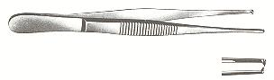

_____________________ ____________________ _____________________________
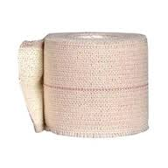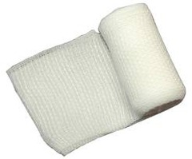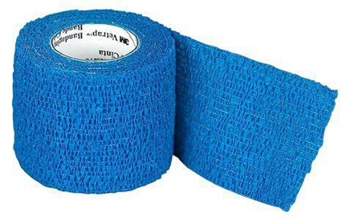

_____________________ _______________________ __________________________

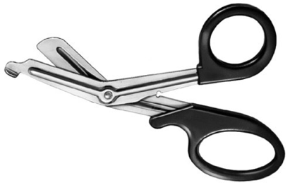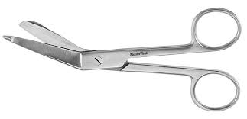

__________________________ _________________________________
28. What are the 4 types of wounds an animal can get? What is the treatment protocol method for each type of wound?
Wound Type Treatment Method

29. Name 6 common pet toxins

30. What are the 4 symptoms/signs of an animal ingesting a toxin?

31. What are the 4 foods that are poisonous to pets?

32. What does CRT stand for? What is the normal value?

33. What is the normal appearance for mucous membranes of horses and pets?

34. What are the 6 categories of Parasites?

35. What are the definitions for the following terms?
- Host:

- Endoparasite:

- Ectoparasite:

36. What are the following parasite eggs?
Word Bank: Flea Larva, Heartworm Microfilaria, Hookworm Egg, Mosquito Larva, Roundworm Egg, Whipworm Egg & Taenia Tapeworm Egg.
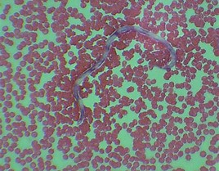 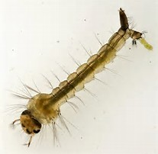 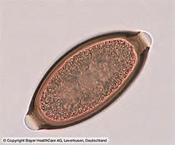

______________________ ______________________ ______________________

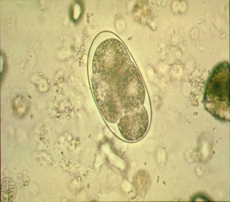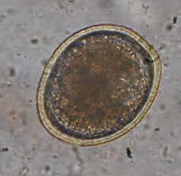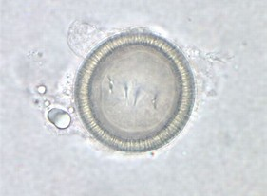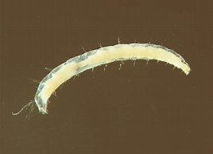

_______________ _______________ _______________ ___________________

37. What are the following parasites?
Word Bank: Flea, Dog Tick, Deer Tick, Demodectic Mite, Blowfly, Coccidia, Giardia, Ear Mite, Heartworm, Hookworm, Roundworm, Sarcoptic Mite, Liver Fluke, Whipworm, Taenia Tapeworm & Mosquito.



   

